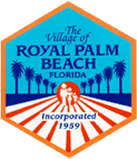

Senior Referral Program

The Senior Referral Program of Royal Palm Beach helps seniors, and their caregivers, identify and access services for their special needs.

This is a free service, no appointment is needed; just stop by the desk.

Tuesdays & Thursdays: 1:00pm to 3:00pm
Royal Palm Beach
Royal Palm Recreation Center
100 Sweet Bay Lane
Royal Palm Beach, FL 33417
For further information Call: 561-790-5188
(call during above times and days only)

